**Course-End Project**

**Deploying Web Application**

Steps to be followed:

1. Prepare the environment
2. Build and push the Docker image
3. Deploy using ECS and Fargate
4. Configure and test the ECS service
5. Verify the application deployment

**Step 1: Prepare the environment**

1. Go to the AWS console and create an EC2 instance of t2.micro

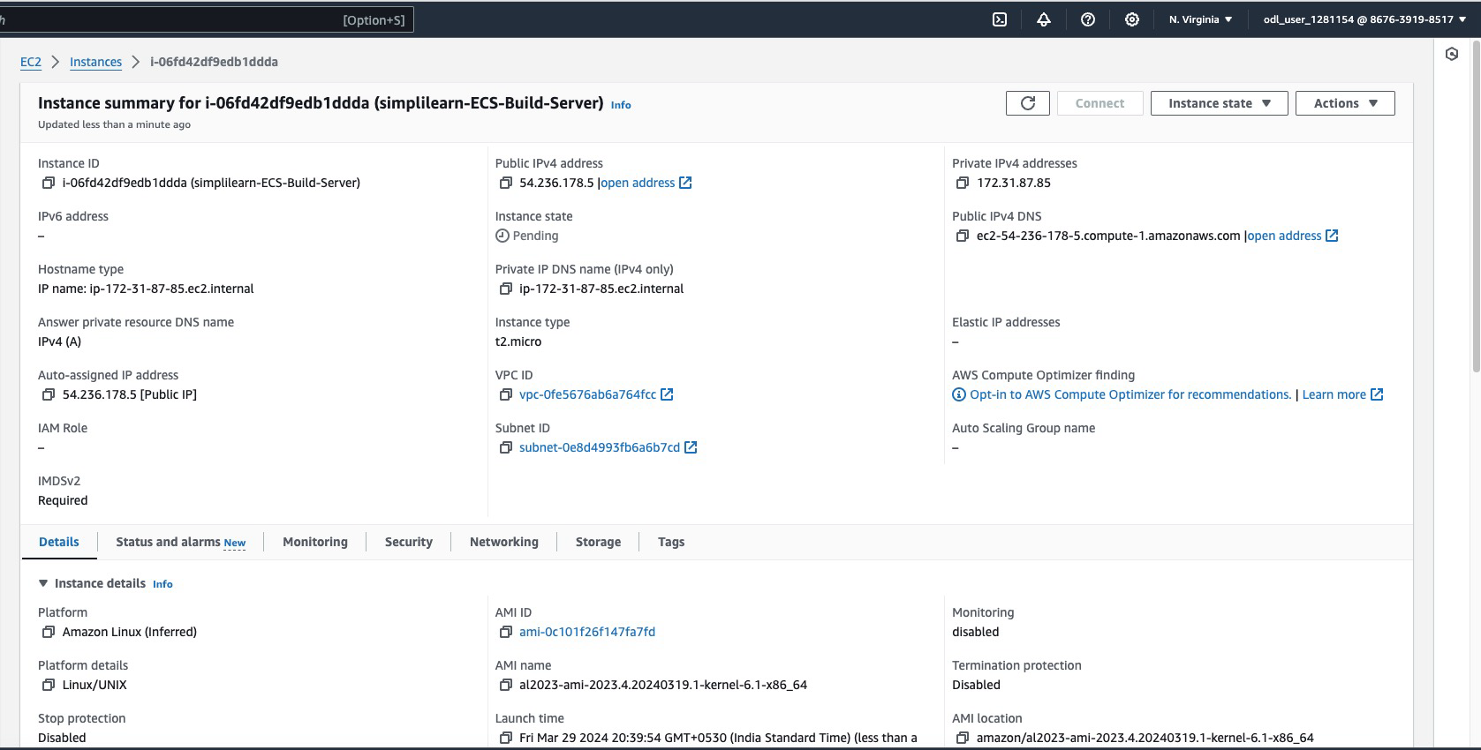

1. Run the command **sudo apt update && sudo apt upgrade -y** to update and upgrade the system packages

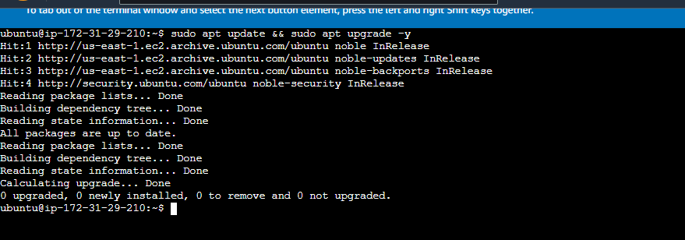

1. Run the command **sudo apt install git -y** to install the latest version of Git on your EC2 Ubuntu system

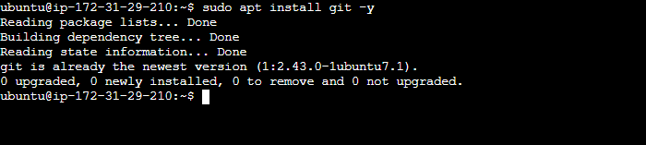

1. Run the command **sudo apt install docker.io -y** to install Docker and its necessary dependencies

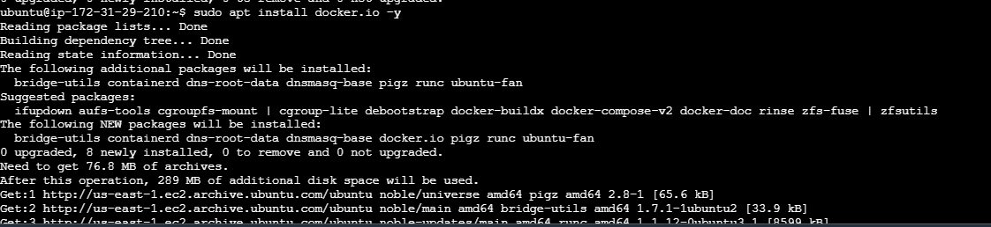

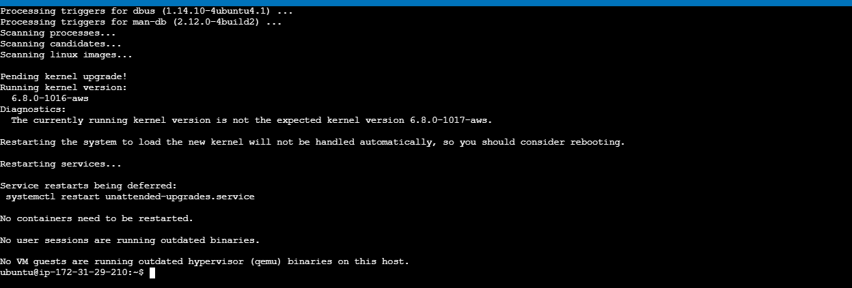

1. Run the command **sudo systemctl start docker** to start the Docker service on your Ubuntu system, allowing you to run the Docker containers

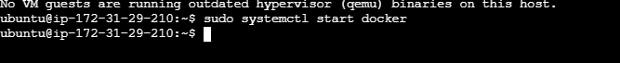

**Step 2: Build and push the Docker image**

* 1. Run the command **git clone** **https://github.com/ramkrishnatest/ECS-Fargate.git** to download the ECS-Fargate project repository from GitHub to your local machine

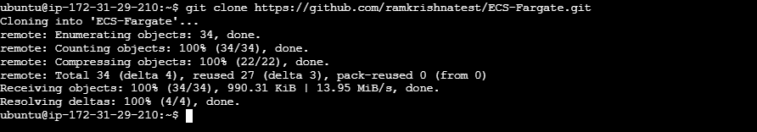

* 1. Run the command **cd ECS-Fargate/** to change your current directory to the ECS-Fargate directory

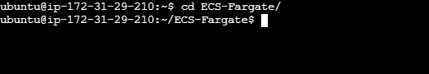

* 1. Run the command **docker build -t deploy** to create a Docker image named **deploy** from the Dockerfile in the current directory

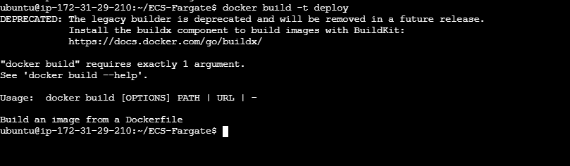

1. Before configuring the AWS CLI, click on **Security credentials**, and then select **Switch role**

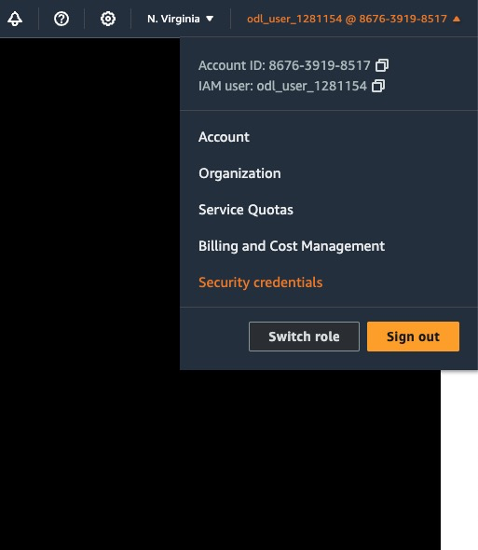

**Step 3: Deploy using ECS and Fargate**

* 1. Navigate to the **Create Repository** page on Amazon ECR, enter the repository name, and configure visibility settings to either **Public** or **Private** to create a new Docker image repository

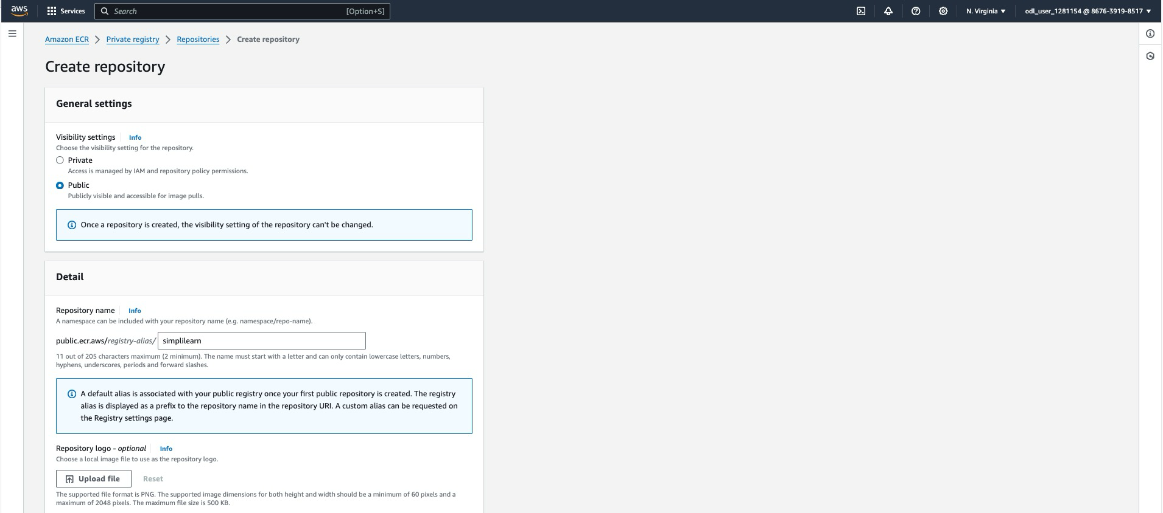

* 1. Click on Repository and view Push commands; you will see the commands (as shown below) to push your Docker image to the ECR repository.

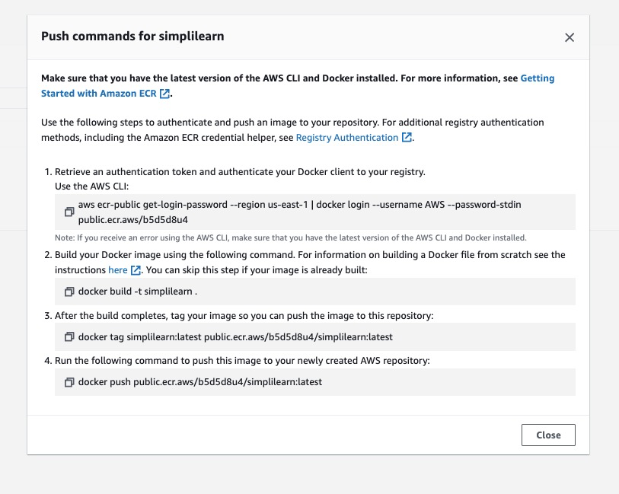

Go back to the EC2 console and tag the Docker image to push to the newly created ECR Registry using push commands displayed in the ECR dashboard

* 1. Run the command **sudo aws ecr-public get-login-password --region us-east-1** | **sudo docker login --username AWS --password-stdin public.ecr.aws/b5d5d8u4** to authenticate your Docker client with AWS ECR as a superuser, enabling you to push and pull images

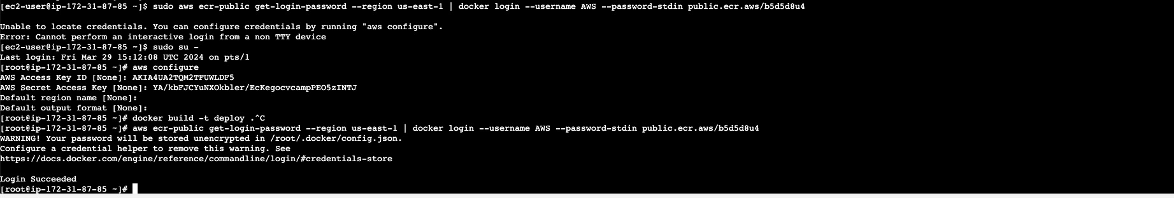

* 1. Run the command **sudo docker build -t simplilearn .** to build a Docker image named **simplilearn** using the Dockerfile in the current directory with superuser permissions, ensuring all necessary Docker operations can execute without permission issues

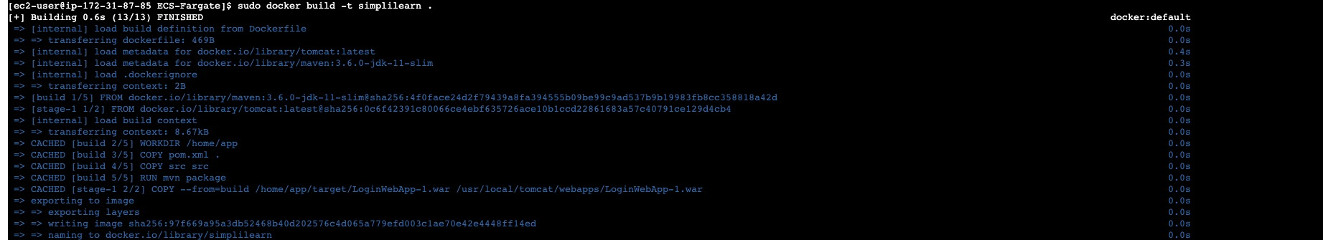

* 1. Run the command **sudo docker push public.ecr.aws/b5d5d8u4/simplilearn:latest** to upload the Docker image named **simplilearn:latest** to your AWS Elastic Container Registry using superuser privileges

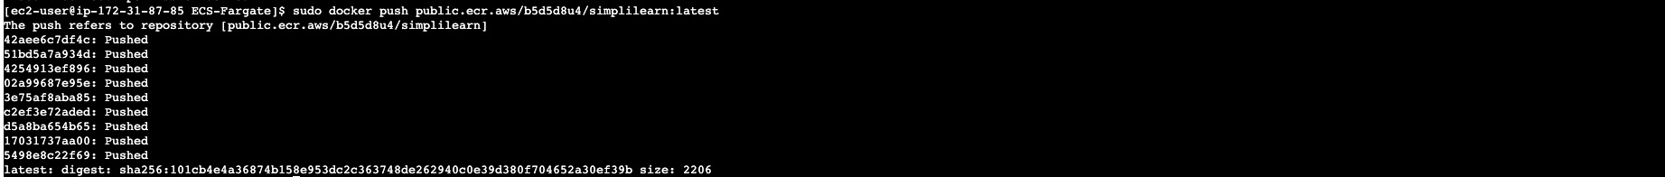

Check and ensure that your image is successfully pushed to the ECR

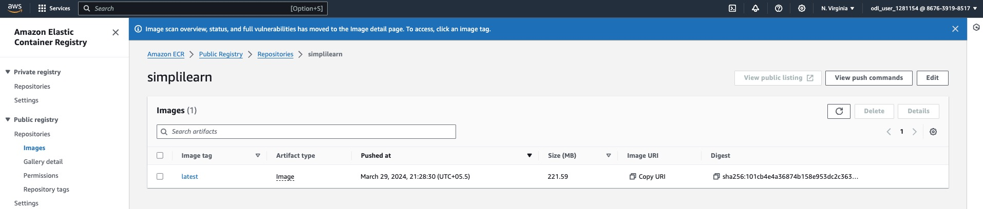

Run the image locally to test and set the security group configuration as open to all TCP

ports for testing

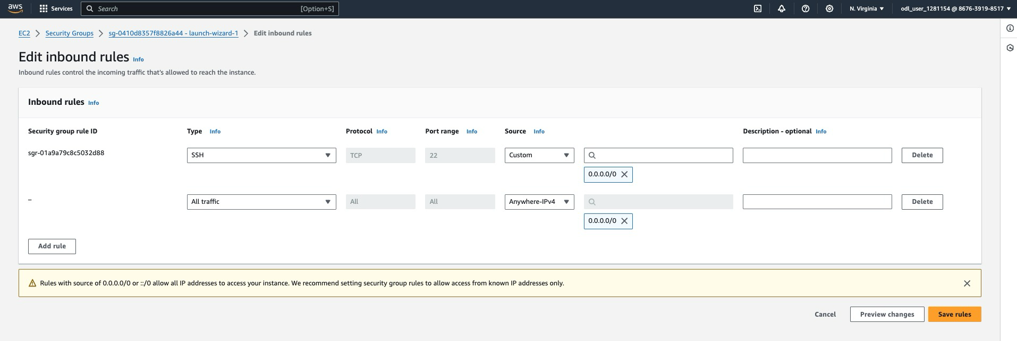

You should be able to open the URL **http://publicip:8089/LoginWebApp-1**.

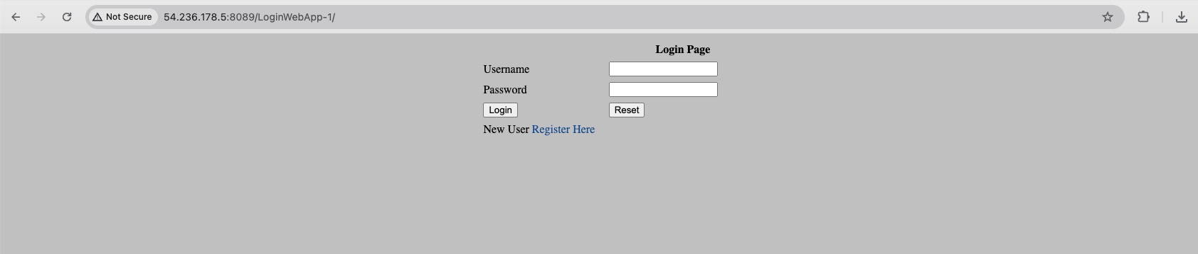

**Step 4: Configure and test the ECS service**

* 1. Navigate to the Amazon Elastic Container Service (ECS) **Create cluster** page, enter **simplilearn-ECS-Cluster** as the cluster name, choose the infrastructure type designed for AWS Fargate, and click **Create** to set up your new ECS cluster

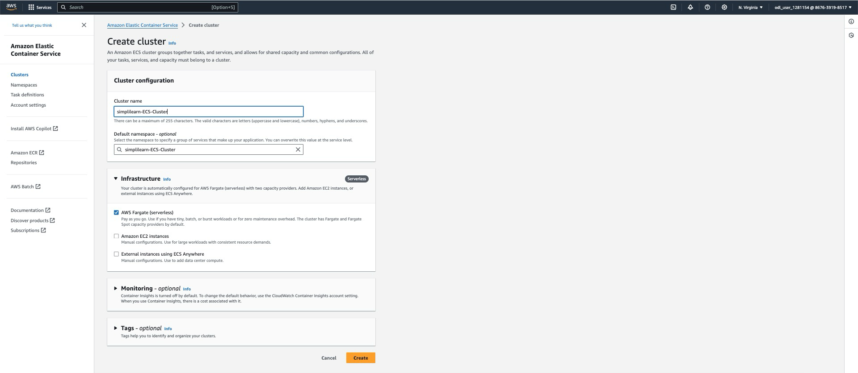

* 1. Navigate to the Amazon ECS console, click on **Task Definitions**, then **Create new Task Definition**. Fill in the task definition family name (Example: **simplilearn-ecs-task**), select the infrastructure requirement such as **AWS Fargate** or **Amazon EC2**, set the operating system to **Linux/x86_64**, and specify other required parameters such as Docker image, CPU and memory allocations, network configurations, logging options, command instructions, and volume settings. Finalize by clicking **Create** to save your new task definition.

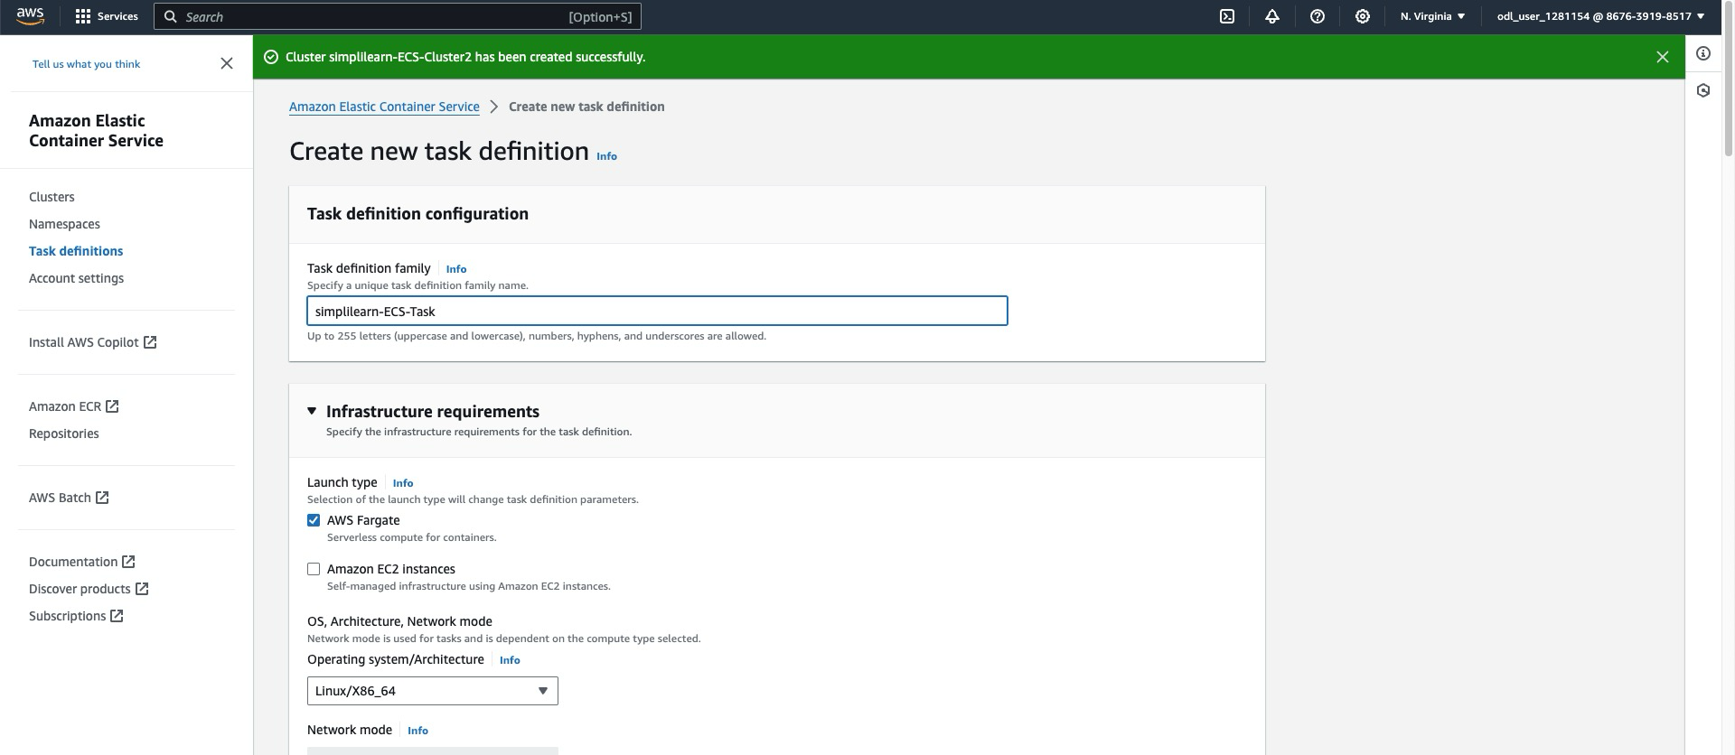

* 1. Navigate to the bottom of the task definition page, select your preferred Network mode, specify 1 vCPU and 3 GB of memory, choose or create an IAM task role and Task execution role, set any necessary task placement constraints, and click **Create** to save and finalize your task definition

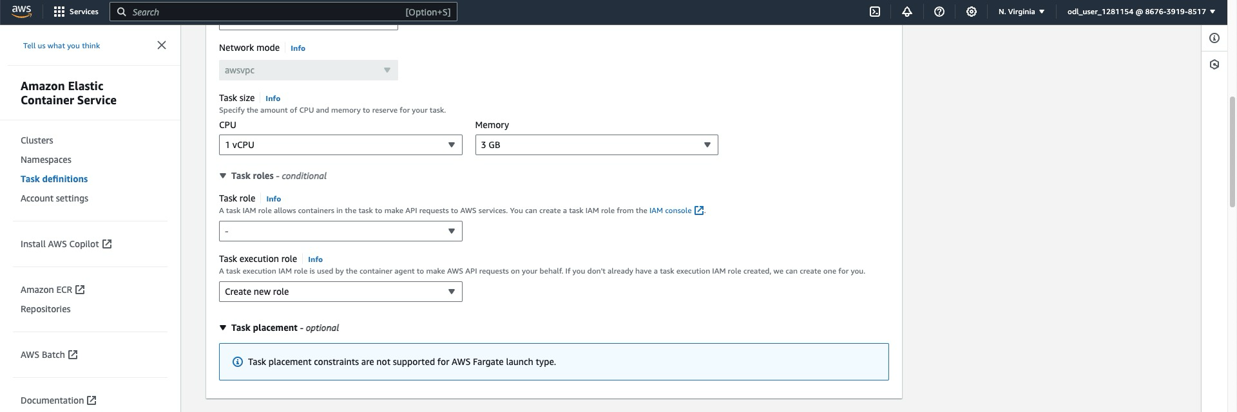

* 1. Navigate to the Container Definitions section, enter **testcase** as the container name, **public.ecr.aws/b5d5d8u4/simplilearn:latest** as the image URI, set the essential status to **Yes**, configure port 8080 for TCP, label it as HTTP for application protocol, allocate 1 vCPU and set a 7 GB memory limit, then click **Add** to apply these configurations

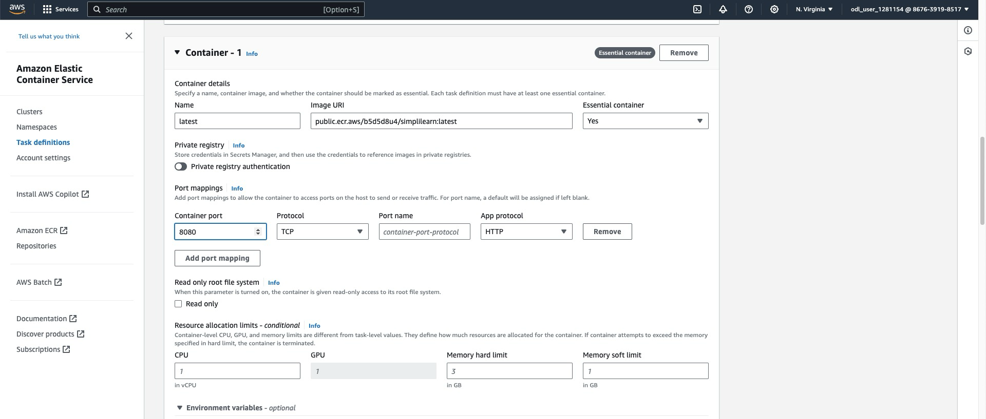

* 1. Enable log collection under the task definition by selecting **Use log collection**, set the key as **awslogs-group** and value as **/ecs/simplilearn-ECS-Task** to configure logs to be sent to Amazon CloudWatch, ensuring you can monitor and troubleshoot your container's activities

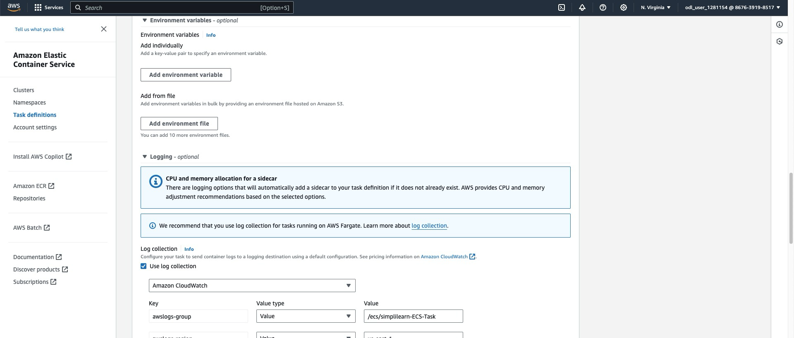

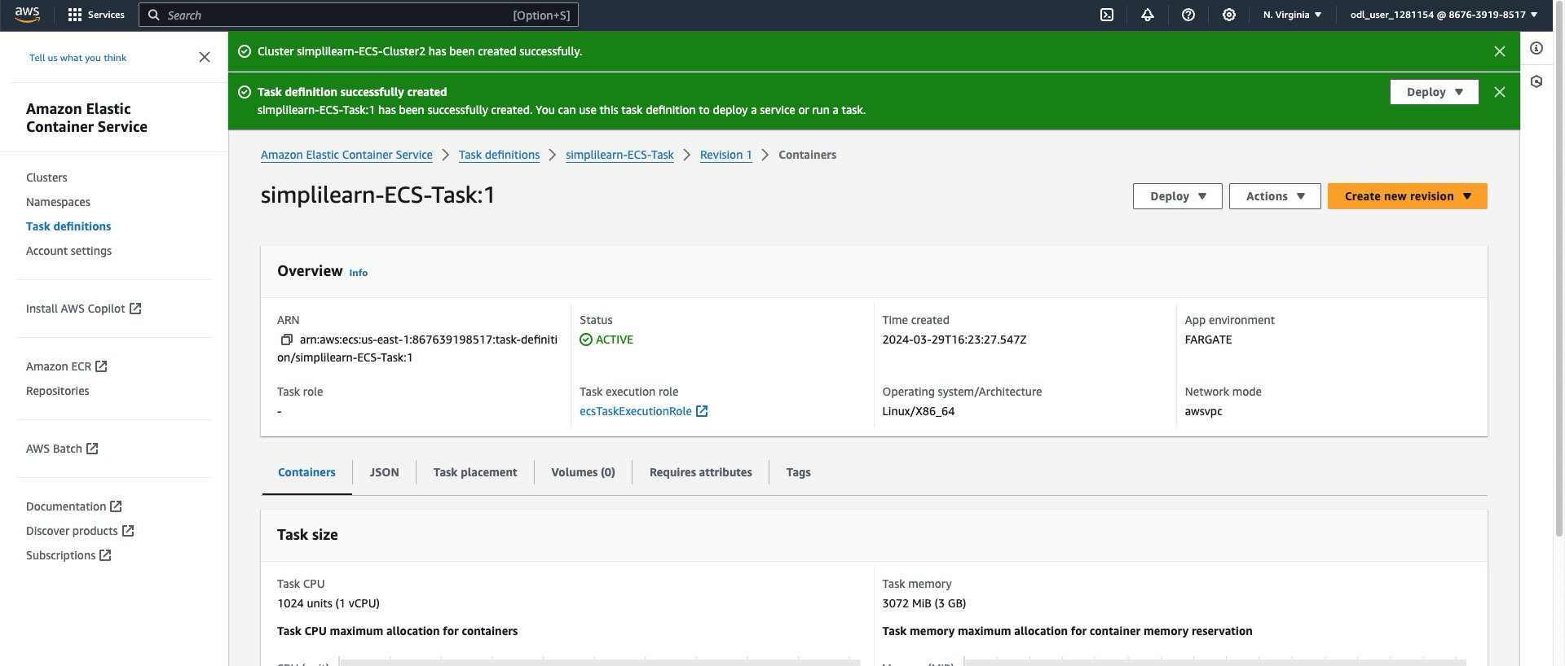

* 1. Click **Run task** under the Actions dropdown to deploy your container using the newly created task definition simplilearn-ECS-Task-1 within the ECS cluster

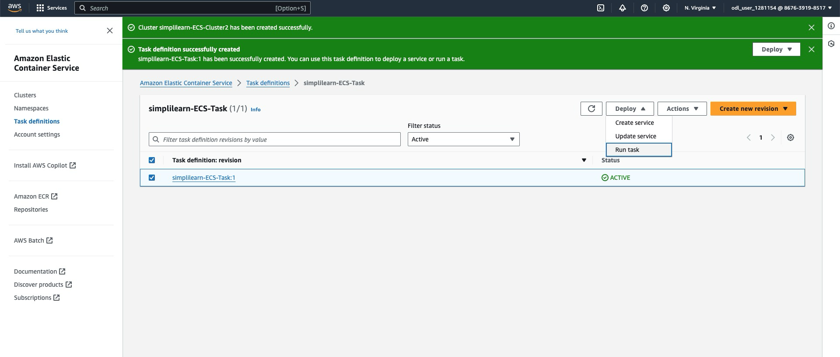

* 1. Select **simplilearn-ECS-Cluster2** from the existing cluster dropdown, ensure **FARGATE** is set under **Capacity provider** with a weight of **1**, and choose your launch type to deploy your task using AWS Fargate in the specified ECS cluster

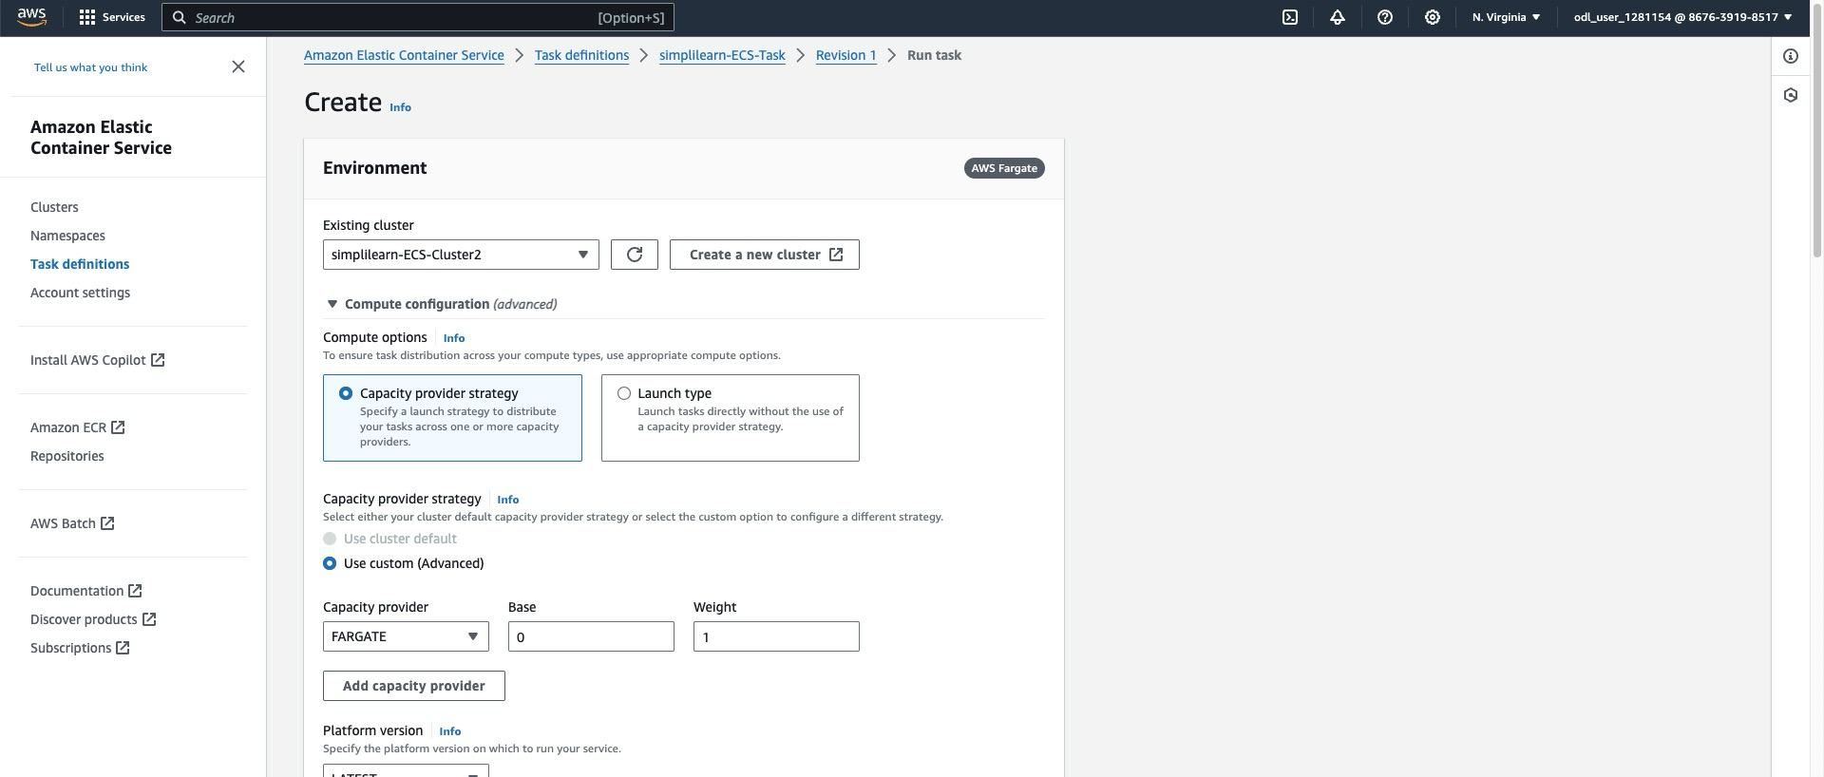

* 1. Choose the **Task** option under Application type, select the **simplilearn-ECS-Task** from the task definition dropdown, set the revision number, specify **1** for the number of tasks to launch, and configure any necessary network settings in the VPC section to deploy your standalone task in the selected ECS cluster

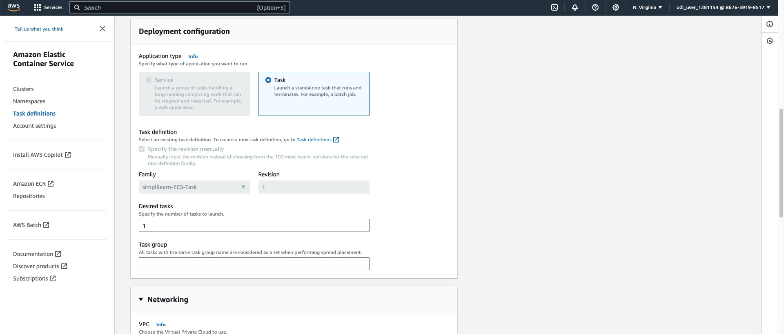

* 1. Select your VPC from the dropdown, choose appropriate subnets for task placement, select an existing security group or create a new one, and decide whether to assign a public IP to ensure proper network configurations for your ECS task deployment

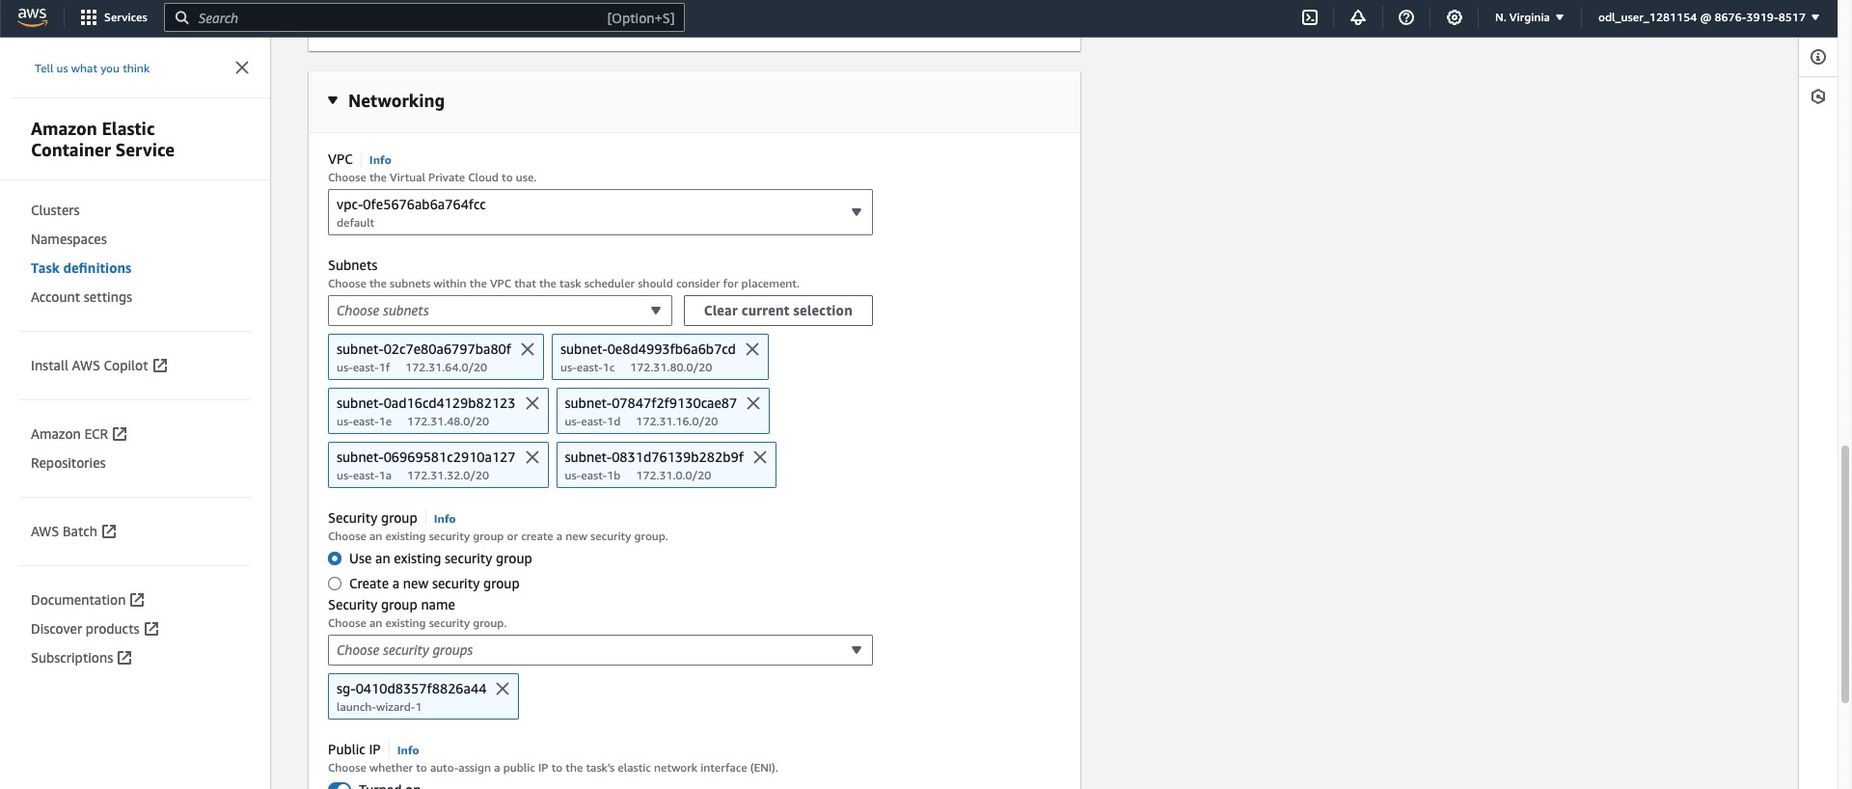

Once you click **Create**, you can see the status of your tasks.  
  
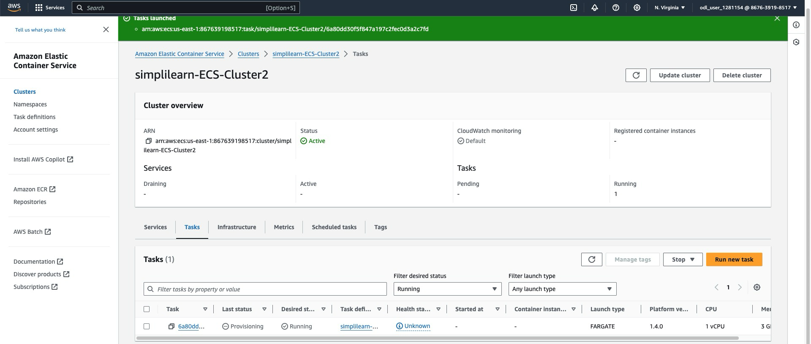

* 1. Click on Task ID to check the logs and to find the public IP

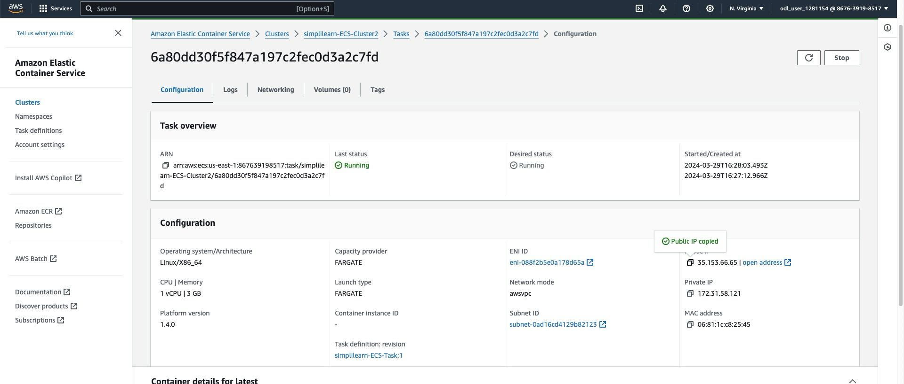

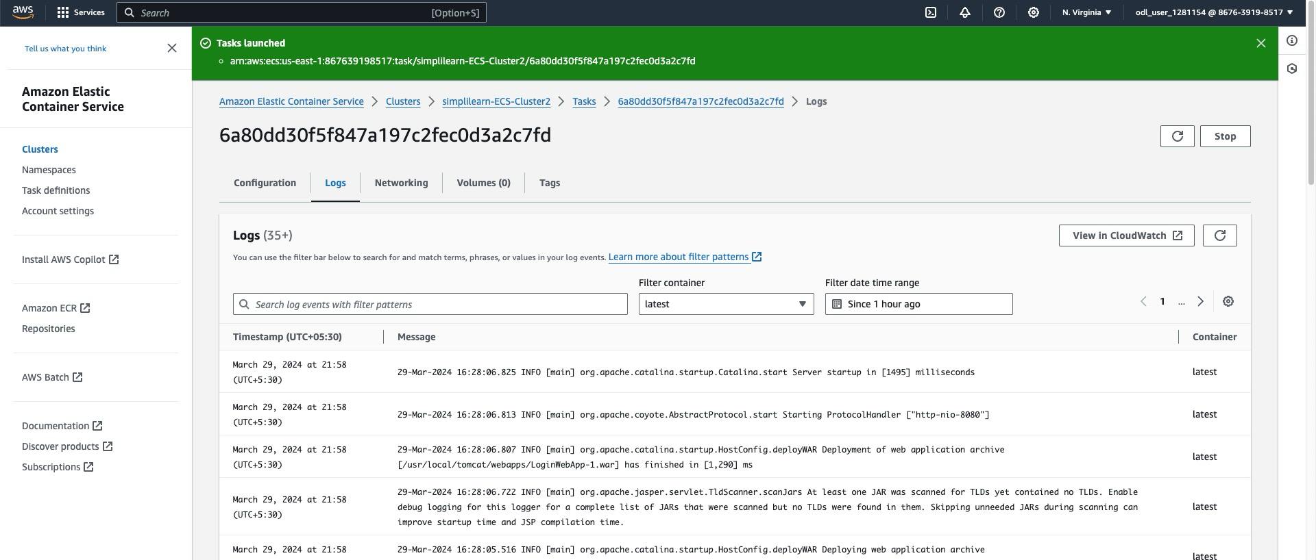

You can browse the URL using **http://35.153.66.65:8080/LoginWebApp-1/**.

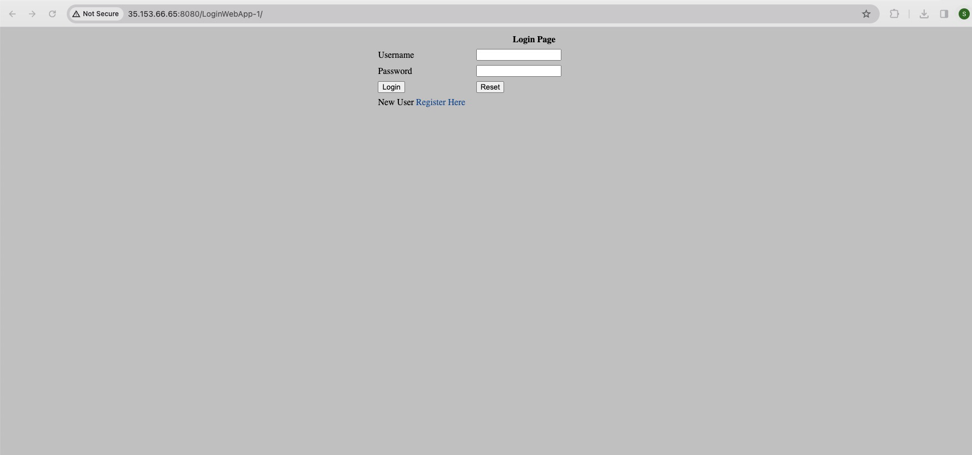

**Step 5: Verify the application deployment**

* 1. Click on the **Create** button under the Services tab to initiate the configuration and deployment of a new service within the **simplilearn-ECS-Cluster2**, ensuring your container tasks are properly managed and scaled

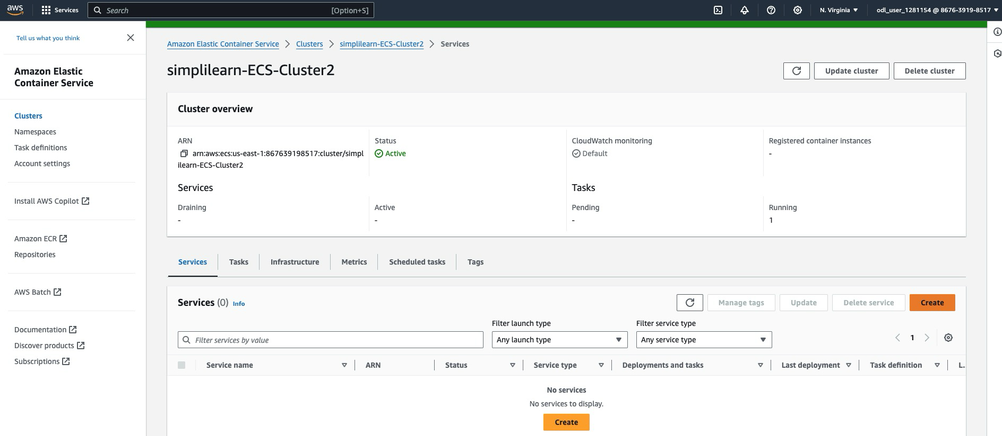

* 1. Select **simplilearn-ECS-Cluster2** for your existing cluster, choose **FARGATE** as your capacity provider with a weight of **1**, and set the platform version to **LATEST** to configure the computing environment for deploying your service in AWS Fargate

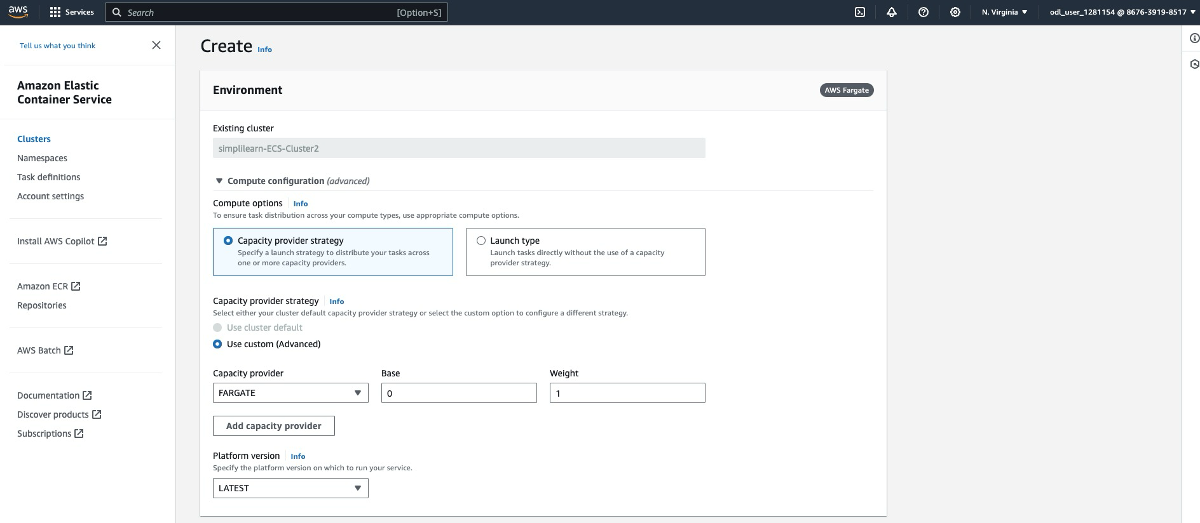

* 1. Choose **Service** for the application type, select **simplilearn-ECS-Task** from the task definition family, set the service name as **simplilearn-service**, choose **Replica** for the service type to maintain a desired number of task copies, and specify **2** for the desired tasks to launch

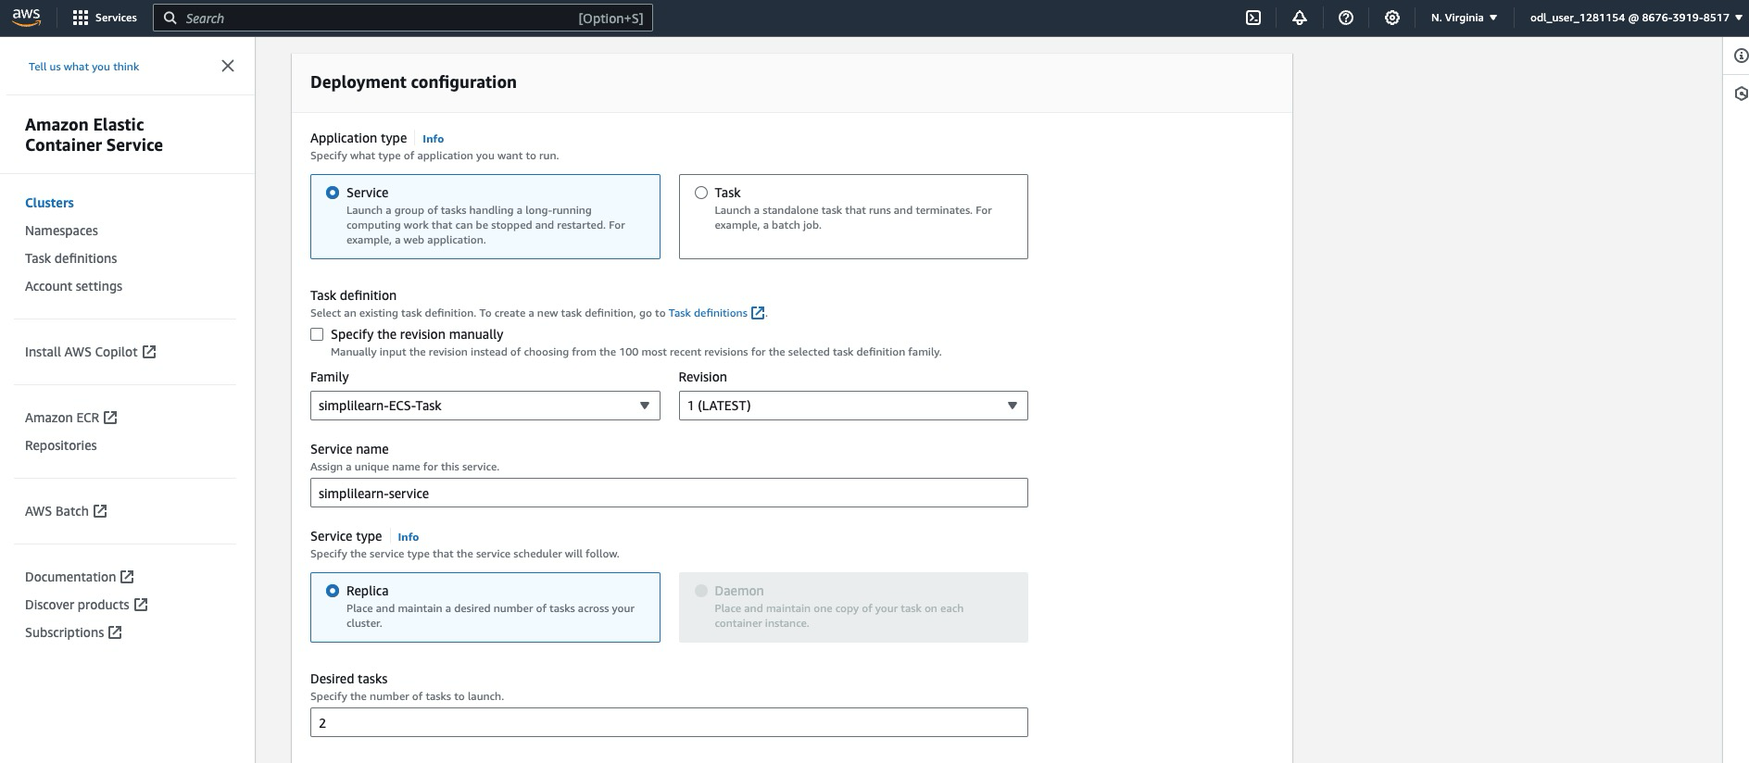

* 1. Select **Rolling update** as the Deployment type, set the minimum running tasks to **100%** to ensure service availability during updates, and adjust the maximum running tasks to **200%** to control scaling during deployment

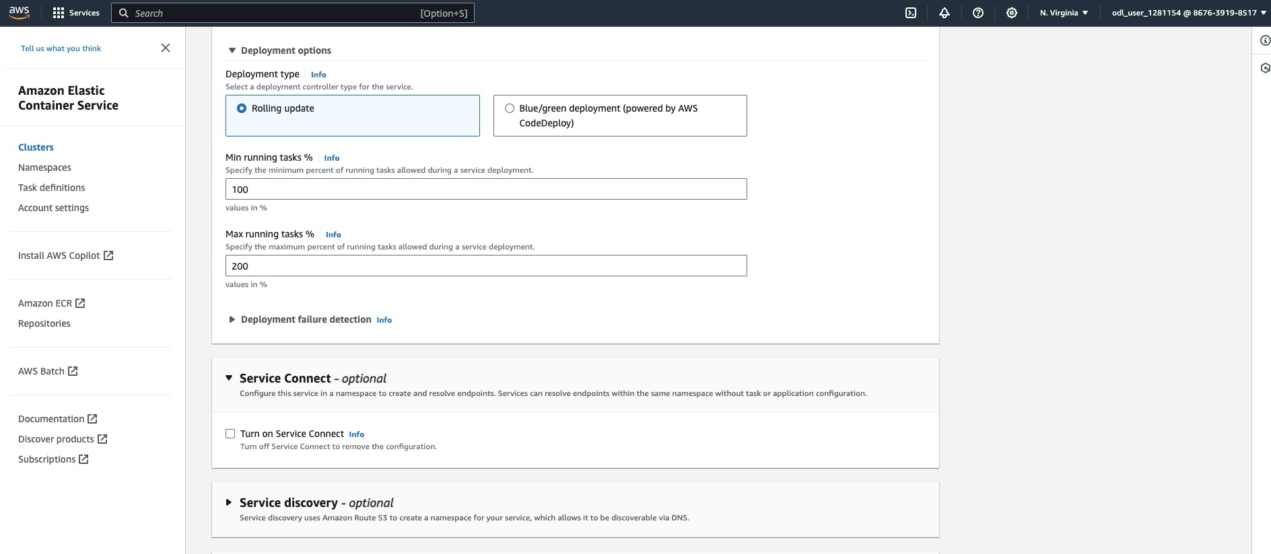

In networking, keep the same security group as Task and EC2

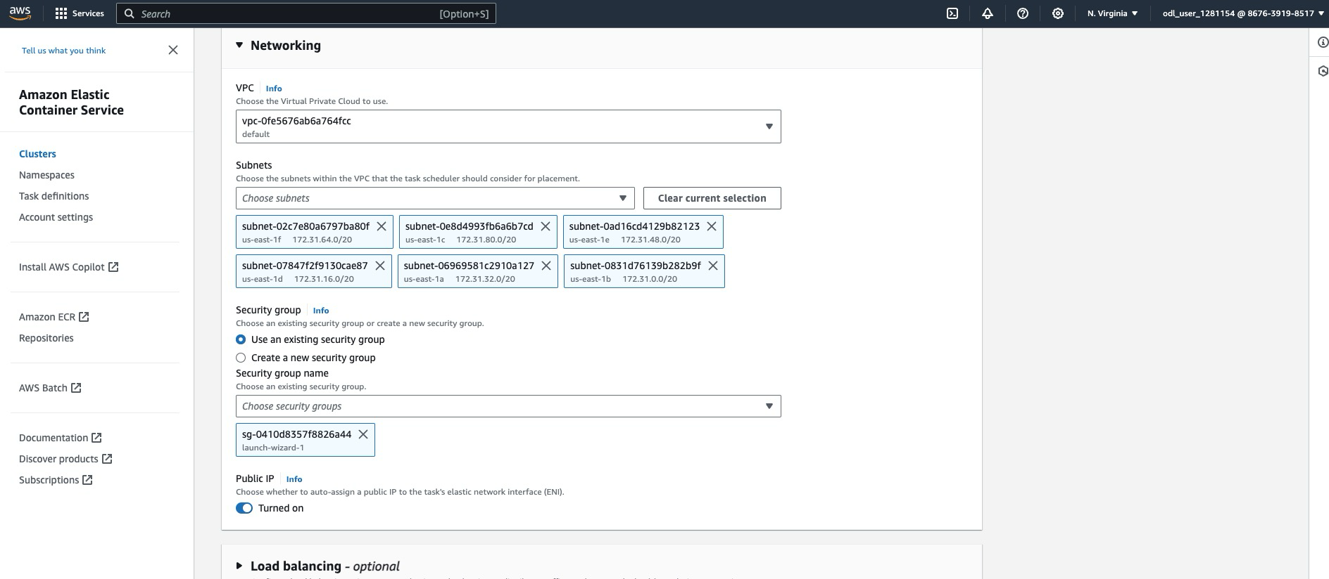

* 1. Select **Application Load Balancer** from the load balancer type dropdown, set the load balancer name as **simplilearn-ECS-ALB**, create a new listener on port **8080** for HTTP traffic, and adjust the health check grace period to ensure optimal performance and availability of your services

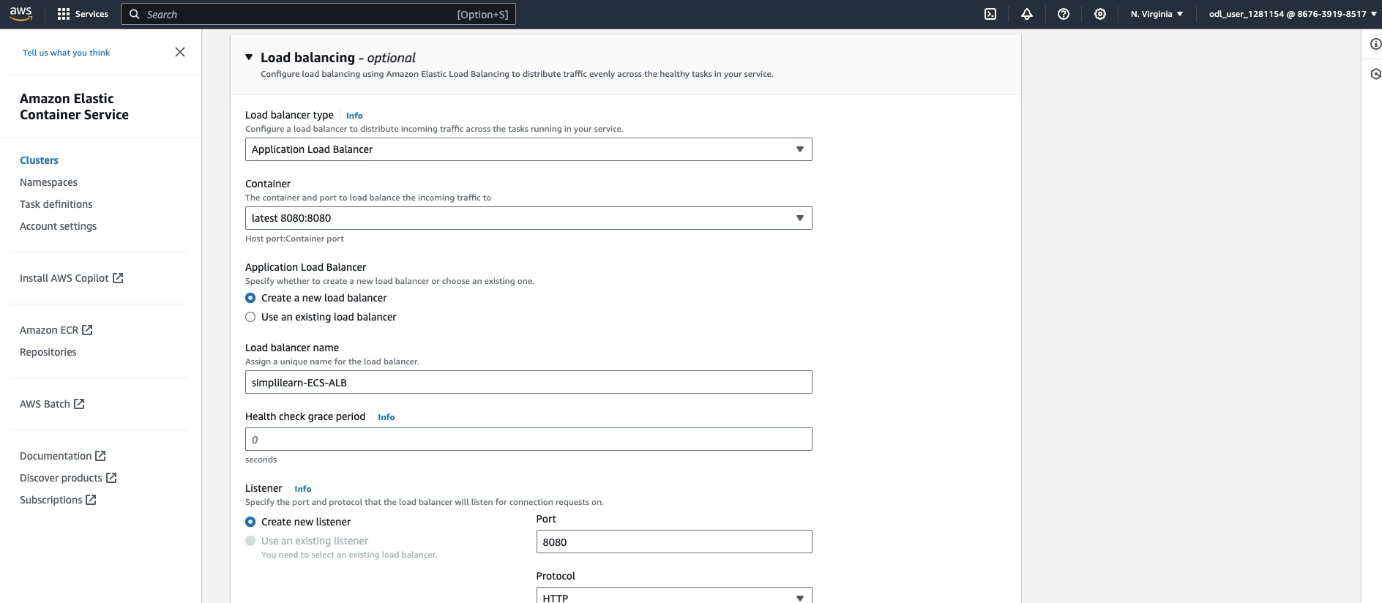

* 1. Create a new target group named **ecs-simplilearn-target** for routing HTTP requests, set the health check path to **/LoginWebApp-1/** with HTTP protocol, and configure the deregistration delay to 300 seconds (about 10 minutes) to manage how traffic is directed to your service's tasks efficiently

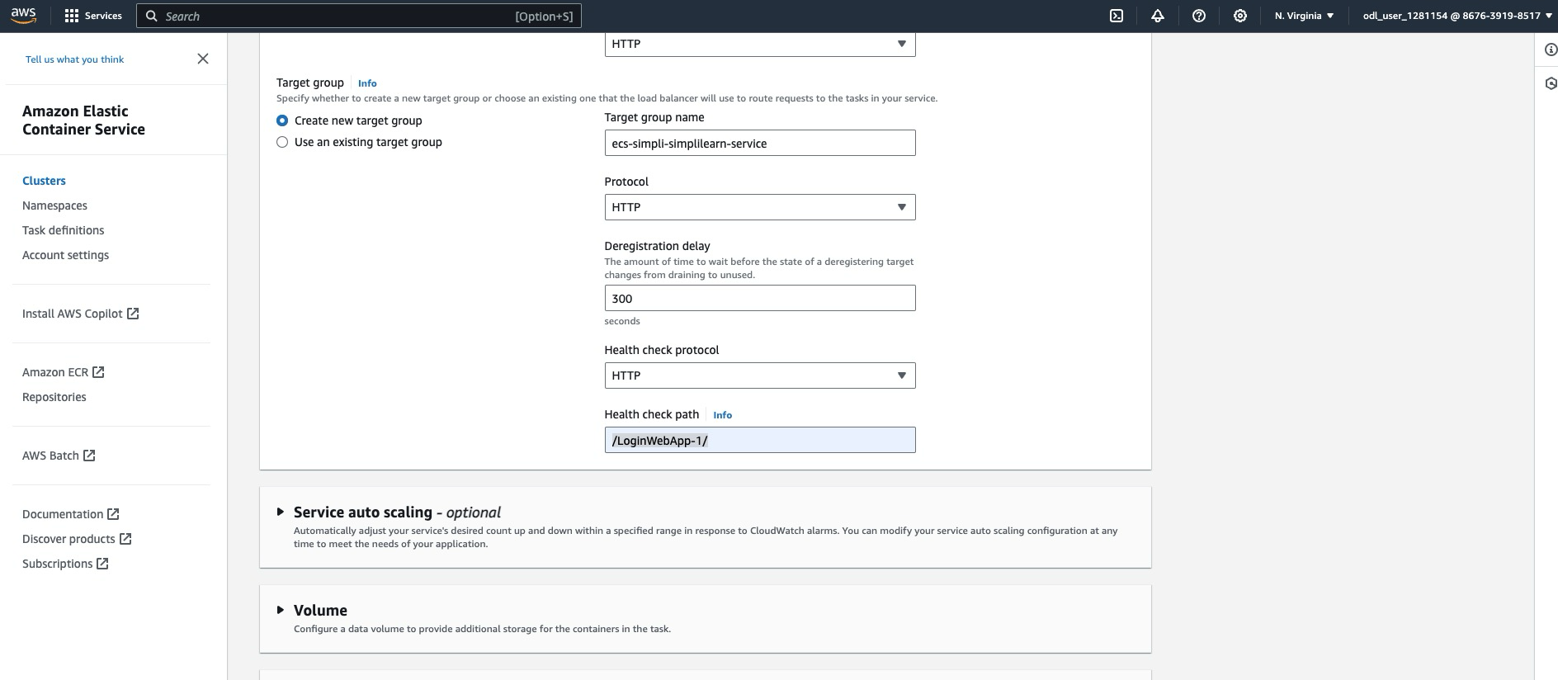

* 1. Once you set the above values in the service definition, click on **Create** to finish creation. It will take some time to create the service and Loadbalancer components.

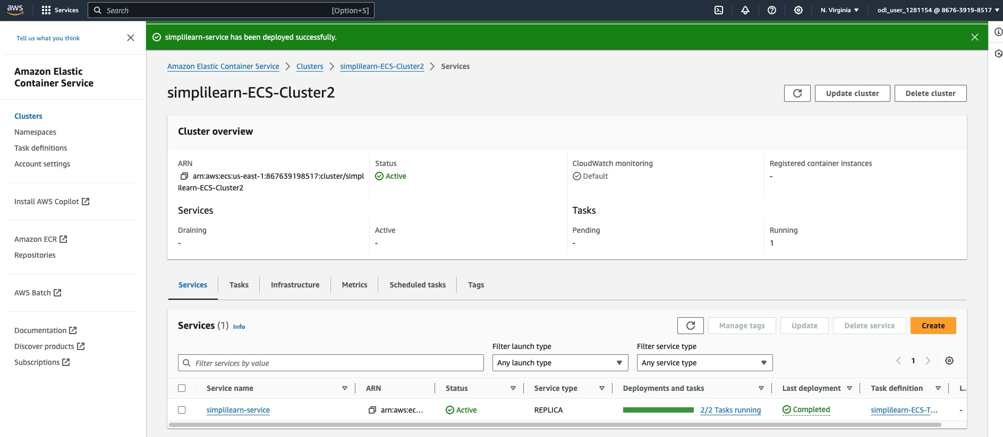

Check Loadbalancer health; it should be healthy.

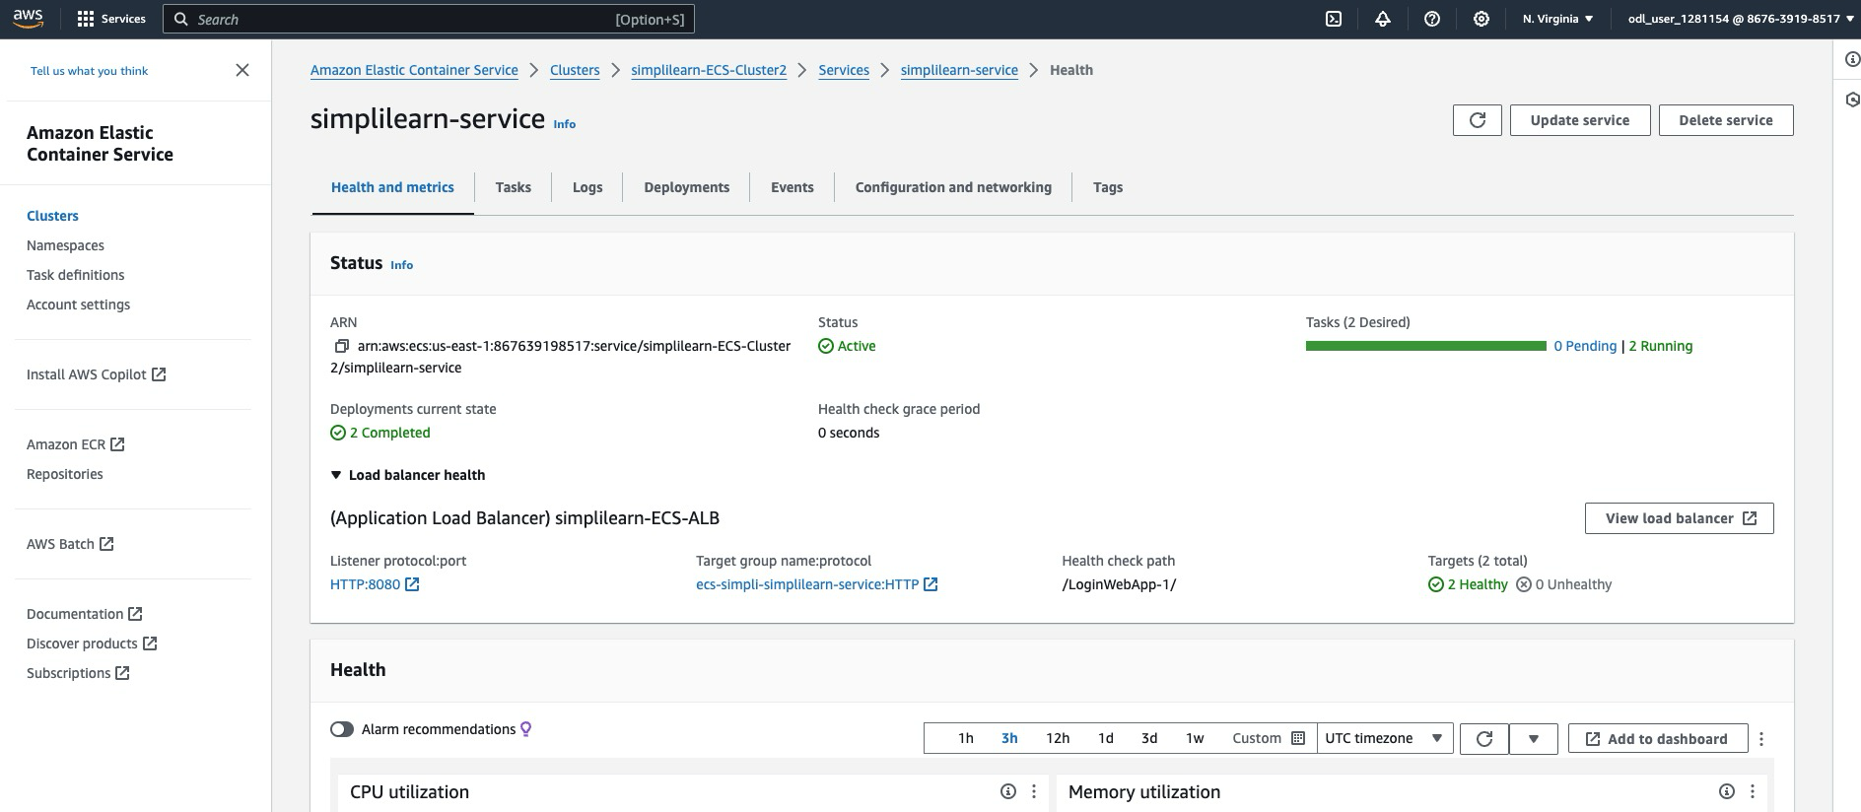

* 1. Click on the Loadbalancer and copy the DNS for Loadbalancer

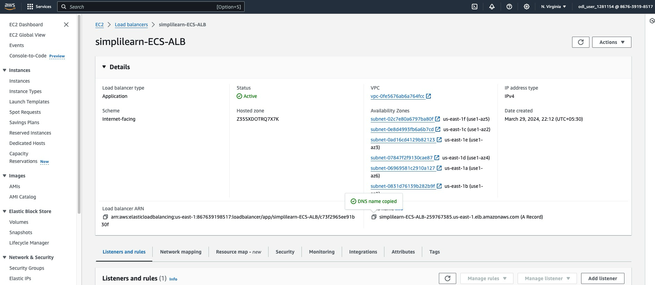

* 1. Navigate to your browser and type the URL **http://simplilearn-ecs-alb-259767385.us-east-1.elb.amazonaws.com:8080/LoginWebApp-1/** to access the login page of the web application deployed on AWS ECS using an application load balancer

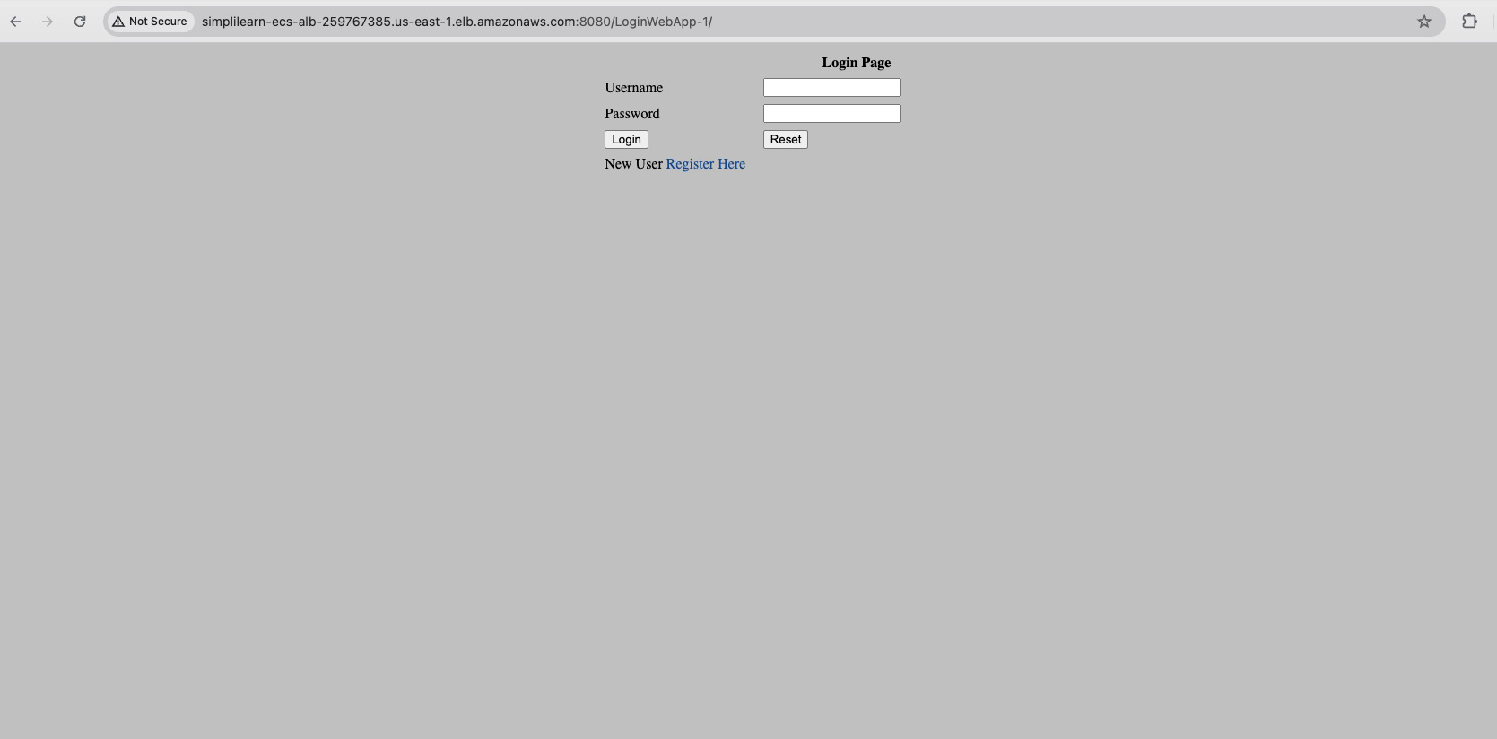

By following these steps, you have successfully deployed a web application using Amazon ECS with Fargate for automated scaling and management. This end-to-end process involved setting up an EC2 instance, building and pushing a Docker image to Amazon ECR, creating an ECS task definition and service, and utilizing an application load balancer to manage incoming traffic.